**SNC1P0 Atom Builder Activity Name:________________ Date:__________**

**Learning Goals:** To develop an understanding of how protons, electrons and neutrons make up the structure of an atom.

**Success Criteria:**

I can identify where protons, electrons and neutrons are located in an atom.

I can identify the **Atomic Number** and type of **element** an atom is from its proton number.

I can determine the **Mass Number** of an atom from its proton and neutron number.

I can balance the number of electrons and protons in an atom to make the atom neutral.

Go to the Colorado Phet Atom Builder link on Google Classroom. You will see the following screen.

Turn on: Net Charge and Mass Number and click on Show Element and Neutral/Ion.

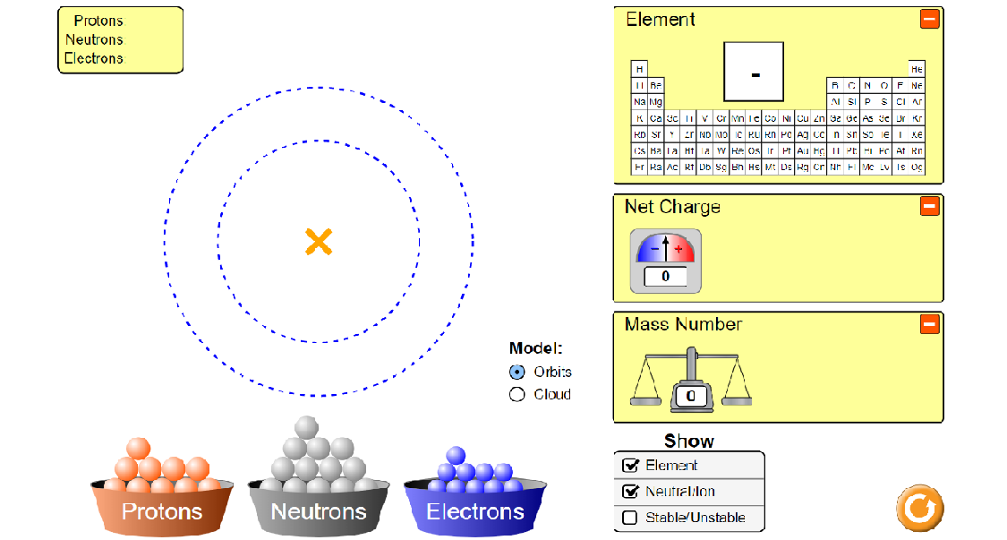

1. Try to create an atom by dragging protons, neutrons and electrons onto the model.

Where do the protons go? __________________________________________________

Where do the neutrons go?_________________________________________________

Where do the electrons go?_________________________________________________

Reset your atom by clicking on the arrow.

1. Create a neutral Lithium atom. Lithium has an atomic number of 3. To make a neutral Lithium atom you need 3 protons, 4 neutrons and 3 electrons. Sketch your completed atom when done and label the protons, electrons and neutrons.

Sketch: What is the mass number of the Lithium atom?___

What is the net charge?_________

1. Create a neutral Boron atom. Boron has an atomic number of 5. To make a neutral boron atom you need 5 protons, 6 neutrons and 5 electrons. Sketch your completed atom when done and label the protons, electrons and neutrons.

Sketch: What is the mass number of the Boron atom?___

What is the net charge?_________

1. Create TWO more neutral atoms of your choice from the 1st or second row of the periodic table (up to element number 10- Neon). Use your Big Chart to help you find the number of protons, electrons and neutrons.

Atom:___________________ (element Name)

Sketch: What is the mass number of your atom?___

What is the net charge?_________

Atom:___________________ (element Name)

Sketch: What is the mass number of your atom?___

What is the net charge?_________

**Summary Questions:**

1. What particles contribute to the MASS of your atoms? Give an example from your diagrams.
2. How do you make an atom neutral? What particles are involved? Give an example from your diagrams.

________________________________________________________________________